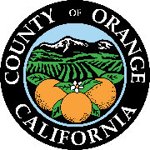

dylan wright
director
oc community resources

cymantha atkinson
assistant director
oc community resources

julie lyons
director
administrative services

andi bernard
director
oc animal care

julia bidwell
director
oc housing & community development

renee ramirez
director
oc community services

stacy blackwood
director
oc parks

julie quillman
county librarian
oc public libraries

1501 e. st. andrew place
santa ana, ca 92705-4930
phone: 714.566.3000
OC Public Libraries - Library Advisory Board
2022 Committees

Board Officers
Elected at the February 24, 2022 LAB Meeting
Chair: Christine Marick
Vice-Chair: Anne Figueroa
Secretary: Hong Alyce Van

Executive Committee
Chair: Christine Marick (Brea)
Vice-Chair: Anne Figueroa (RSM)
Secretary: Alyce Hong Van (Stanton)
Carol Moore (LW)
Tammy Kim (Irvine)
Becky Gomez (Tustin)
Debbie Baker (LP)
Robbie Pitts (VP)
Thu-Ha Diedre Nguyen (GG)

