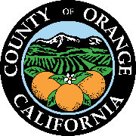

dylan wright
director
oc community resources

cymantha atkinson
assistant director
oc community resources

julie lyons
director
administrative services

andi bernard
director
oc animal care

julia bidwell
director
oc housing & community development

renee ramirez
director
oc community services

stacy blackwood
director
oc parks

julie quillman
county librarian
oc public libraries

1501 e. st. andrew place
santa ana, ca 92705-4930
phone: 714.566.3000
OC Public Libraries - Library Advisory Board
2021 Committees

Board Officers
Elected at the January 21, 2021 LAB Meeting
Chair: Elaine Gennawey
Vice-Chair: Christine Marick
Secretary: Anne Figueroa

Executive Committee
Chair: Elaine Gennawey (LN)
Vice-Chair: Christine Marick (Brea)
Secretary: Anne Figueroa (RSM)
Richard Hurt (AV)
Anne Hertz (CYP)
Kim Constantine (FV)
Debbie Baker (LP)
Carol Moore (LW)
Alyce Hong Van (Stanton)

